# Work

**Work and Energy**

* **Work** is done when a **force** produces **motion** in a body.
* Work done in moving a body is equal to the product of force exerted on the body and the distance moved by the body in the direction of force.

Work  Force Distance W  F  s

* Work is a **scalar** quantity. It has only magnitude and no direction.
* Its SI unit is **joule** (J).
* **One joule of work** is said to be done on an object when a force of 1 N displaces the object by 1 m along the line of action of force.
* Work done by a force can be positive, negative or zero.
* It is **positive** when a force acts in the direction of motion of the body.
* It is **negative** when a force acts opposite to the direction of motion of the body.
* It is **zero** when a force acts at right angles to the direction of motion of the body.

# Energy

* We define energy as the **ability to do work**.
* The amount of energy possessed by a body is the amount of work it can do when that energy is released.
* Energy is a **scalar** quantity.
* Its SI unit is **joule** (J). 1 kJ = 1000 J
* The main forms of energy are kinetic energy, potential energy, chemical energy, heat energy, light energy, sound energy, electrical energy and nuclear energy.

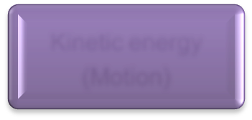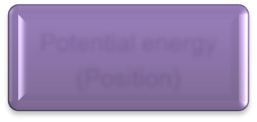

Energy

Kinetic energy

(Motion)

Potential energy

(Position)

# Kinetic Energy

* The energy possessed by a body on account of its **motion** is known as **kinetic energy**.
* Kinetic energy of a body is directly proportional to
  + the **mass** of the body
  + the **square of the velocity** of the body
* Kinetic energy possessed by a body of mass ‘m’ moving with a velocity ‘v’ is given by the formula:

Kinetic Energy =

1 mv2

2

# Potential Energy

* The energy possessed by a body because of its **position** or **configuration** is known as **potential energy**.
* The work done in raising an object from the ground to a point against gravity is called gravitational potential energy.
* Potential energy of a body of mass ‘m’ raised to a height ‘h’ above the surface of the Earth is given by the formula:

## Potential Energy = m g h

where ‘g’ is the acceleration due to gravity.

## Law of conservation of energy:



Energy can neither be created nor destroyed; it can only be converted from one form to the other.

* Sum of kinetic energy and potential energy of an object is its total mechanical energy.

# Power

* Power is defined as the rate of doing work or the rate of transfer of energy.

Power  Work done

Time taken

or Power  Energy consumed

Time taken

* Power is a **scalar** quantity. Its SI unit is **watt** (W).
* It is said to be one watt when the rate of consumption of energy is 1 Js−1.
* Larger units of power are **kilowatt** (kW), **megawatt** (MW) and **horsepower** (hp). 1 kW = 1000 W

1 MW = 106 W

1 hp = 746 W

# Commercial Unit of Energy

* The commercial unit of energy is **kilowatt hour** (kWh).
* One kilowatt hour is the amount of electrical energy consumed when an electrical appliance with a power rating of 1 kilowatt is used for 1 hour.
* 1 kWh is equal to 3.6 × 106 J of energy.
* 1 kilowatt hour of electrical energy is commonly known as **1 unit**.